Featured Press List Component

**Page Reference** - <https://www.ancestry.com/corporate/au>

**AEM URL** - <https://author-ancestry-dev2.adobecqms.net/content/ancestry-corp/us/en/global-newsrooms/au/newsroom.html?wcmmode=disabled>

This Component will use only in newsroom pages for AU, CA, and UK countries.

We just need add or drag this component.

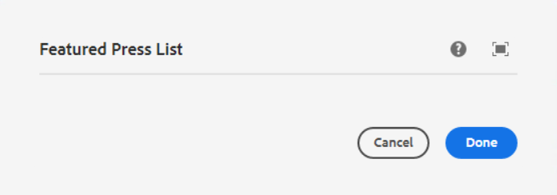

The latest 3 Press-releases (As per date) will be displayed here.

For E.g.- If this is the AU newsroom page then the latest 3 AU press-release will be shown here.

